Project Ireland (werkboek)
Task 1: The Celts
Watch the video:
https://www.youtube.com/watch?v=lmYQMJi30aw celtic
- Wie/wat waren de kelten?
- Waarom denkt men dat ze zulke dappere krijgers waren?
- Geef drie rollen (in het Engels) die je als kelt kon hebben in een stam.
- Ierland heeft nu nog sterke Keltische invloeden, zeker vanuit hun mythologie. Hoe komt het dat vooral Ierland nu nog zo sterk geassocieerd wordt met de Kelten en niet landen zoals Frankrijk en Spanje?
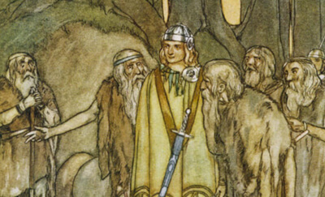

We are going to read a couple of stories, mostly about Finn McCool (Fionn Mac Cumhaill in Irish Gaelic). He is one of the most important and well-known characters in Irish folklore/mythology. He was a wise and fearless warrior with a band of followers called the Fianna, and in some stories he was even depicted as a giant! The time period where they mostly spoke of Finn was called the Fenian Cycle.

Story 1: The Giant’s Causeway (Task 2)
Vraag Nederlands = Nederlands Antwoord
Vraag Engels = Engels antwoord
- Omschrijf Fionn’s persoonlijkheid met minimaal twee verschillende karakteristieken.
- Wat zijn een paar bovenmenselijke dingen die Fionn kon doen?
- Waarom durfde Fionn het niet om een gevecht aan te gaan met Fathach Mór?
- Describe Bláithín’s plan to fool Fathach Mór, use the words oatcakes and cradle in your description.
- What did Fionn do to rid the giant of his powers?
- What happened with the Giant’s Causeway?
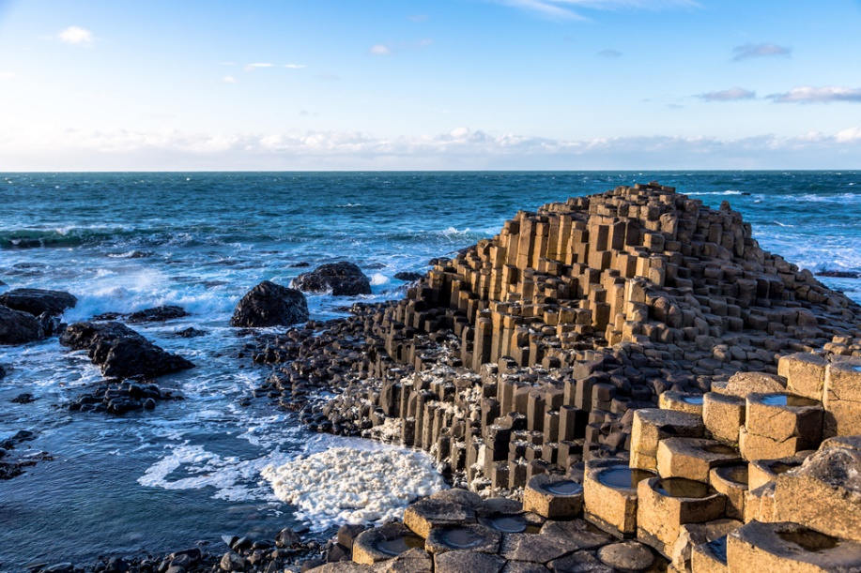

Story 2: The bodach of the grey coat (task 3)
Vraag Nederlands = Nederlands Antwoord
Vraag Engels = Engels antwoord
- Waarvoor was Caol an Iarainn gekomen?
- Omschrijf de vreemde man die Fionn tegenkwam.
- Aan wat voor mensen werd de naam ‘Bodach’ vaak gegeven?
- Waarom voelde de koning van de Grieken zich beledigd dat ze de Bodach gekozen hadden?
- Why was Caol an Iarainn so frustrated during the race? Give at least two examples.
- Why did Fionn mistake the Bodach for the prince?
- Wie bleek de Bodach écht te zijn?

Story 3: Tír Na N-Òg (Task 4)
Vraag Nederlands = Nederlands Antwoord
Vraag Engels = Engels antwoord
- Waarom had de koning ervoor gezorgd dat zijn dochter een varkenshoofd kreeg?
- Wat was de enige manier om Niamh’s betovering ongedaan te maken?
- Wat was zo speciaal en magisch aan de plek Tír na n-Óg?
- Waarom wilde Oisín terug naar Ierland?
- Welke waarschuwing gaf Niamh hem?
- Wat gebeurde er toen Oisín van Niamh’s witte paard viel?
- At the end, Oisín was helped by the holy Patrick, also called Saint Patrick. Who was Saint Patrick and what was he famous for? Use Google.

B) Look up these words and write down the meaning:
1. Polytheism:
2. Monotheism:
C) This story lets us know about a giant cultural shift in Ireland that happened within a couple of hundred years. Explain what had changed and use the words polytheism and monotheism in your answer.

Task 5 – Listening
Celtic Woman wrote a song about Tír Na N-Òg.
https://www.youtube.com/watch?v=zcLYpw8adtA
Click on the link and listen to the song. You can find the lyrics below. It is partly sung in made-up gibberish that resembles Irish Gaelic.

Sha ta co ti oh scum ne rivna  Sha ta co ti oh nugga Tír na nÓg  Sha ta co ti oh scum ne rivna  Nug a Tír na nÓg  Come, my love, our worlds will part  The gods will guide us across the dark  Come with me and be mine, my love  Stay and break my heart  From the shores through the ancient mists  You bear the mark of my Elven kiss  Clear the way, I will take you home  To eternal bliss  Sha ta co ti oh scum ne rivna  Sha ta co ti oh nugga Tír na nÓg  Sha ta co ti oh scum ne rivna  Nug a Tír na nÓg  Sha ta co ti oh scum ne rivna  Sha ta co ti oh nugga Tír na nÓg  Sha ta co ti oh scum ne rivna  Nug a Tír na nÓg  Tír na nÓg, oh  Come beyond the ancient fog  Tír na nÓg, oh  Come with me to Tír na nÓg | Far away from the land you knew  The dawn of day reaches out to you  Though it feels like a fairy tale  All of this is true  Run with me, have a look around  We built our life over sacred ground  Come, my love, our worlds may part  We'll be safe and sound  Sha ta co ti oh scum ne rivna  Sha ta co ti oh nugga Tír na nÓg  Sha ta co ti oh scum ne rivna  Nug a Tír na nÓg  Tír na nÓg, oh  Come beyond the ancient fog  Tír na nÓg, oh  Come with me to Tír na nÓg  Time won't follow the path we came  The world you left, it forgot your name  Stay with me and be mine, my love  Spare my heart the pain  Sha ta co ti oh scum ne rivna  Sha ta co ti oh nugga Tír na nÓg  Sha ta co ti oh scum ne rivna  Nug a Tír na nÓg  Sha ta co ti oh scum ne rivna  Sha ta co ti oh nugga Tír na nÓg  Sha ta co ti oh scum ne rivna  Nug a Tír na nÓg  Tír na nÓg, oh  Come beyond the ancient fog  Tír na nÓg, oh  Come with me to Tír na nÓg  Come with me to Tír na nÓg
- Are the story and the song similar to one another, yes or no? Explain your answer.
- What do you think about the use of music to bring awareness to important cultural aspects?

